December 2022
Media Alert

Skaya Art Agency presents Revival Art, a collection by Yana Rusnak
The artwork will be displayed at Oblong Contemporary Gallery as part of a group festive exhibition from 14th December 2022 until 8th January 2023
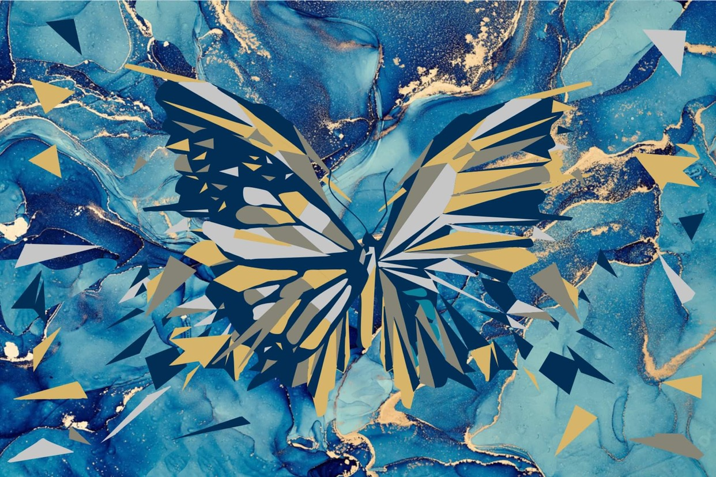
At the moment, 2022 by Yana Rusnak, price on request

Dubai-based boutique art consultant Skaya Art Agency is proud to present Yana Rusnak’s Revival Art (Dynamic Bright Edition) in Dubai at Oblong Contemporary Gallery as part of a group festive-themed exhibition. Yana’s collection on display includes a range of paintings featuring acrylic paint on canvas and aluminium foil which combines animalism and abstract aspects. The exhibition is free to attend and open to the public from 14th December 2022 to 8th January 2023 making it an ideal way for art enthusiasts to spend the holiday season. Visitors can also request an in-person meeting with Yana in advance.
Yana is a renowned Ukrainian contemporary artist whose paintings are an allegory to how human emotions and character are intertwined with the animal world. Every figure in her compositions consists of triangles and each has a special meaning. The values ​​of the triangle are multifaceted involving expressions of creativity, harmony, integration, subjectivity, manifestation, lightening, ascension and more. This universalism captures the themes of magic, occultism, and creativity and unites them in the triangle symbol which is inseparable from the number three representing symmetry, wisdom and understanding.
Each of Yana’s paintings include the colours of two precious metals: gold and silver. Silver symbolizes the colour of the moon and reflects values of innocence, purity, and mercy. Whereas gold represents the splendor and radiance of the sun, and a highly valuable and distinctive quality that does not deteriorate. By fusing figurative and abstract elements Yana’s artwork utilizes the best traditions of contemporary art and attempts to create a ‘dialogue with the universe’. Consequently, the artwork involves visual elements of music, light, nature and the galaxy revealing glimpses of the life-affirming emotion of golden energy. Moreover, each of Yana’s artworks also contain a gold nugget.
Yana’s work has had international appeal with her art being held in private collections worldwide and in commercial buildings in Miami, New-Deli, Cairo, Beirut, Moscow, Riyadh, Kiev, London, and Geneva. Revival Art (Dynamic Bright Edition) by Yana Rusnak presented by Skaya Art Agency can be viewed from 14th December 2022 until 8th January 2023 as part of the festive group exhibition at Oblong Contemporary Gallery. The launch night will take place on 13th December 2022 and will include refreshments.

To find out more visit: https://www.skayagallery.com .For more information about Yana Rusnak please visit: https://www.skayagallery.com/artists/32-yana-rusnak/biography/

Exhibition Information:
Opening Night: 13th December 2022
Time: 14th December 2022 - 8th January 2023, 10am – 10pm (daily)
Venue: Oblong Contemporary Gallery, Bluewaters Island, R29 Bluewaters Boulevard, Dubai
For more information, please visit: https://www.skayagallery.com

Click here for high-resolution images.
-END-
Notes to editor:
About Skaya Art Agency:
Founded in 2016 by Anastasia Kopijevskaja, Skaya Art Agency is a Dubai based boutique art consultancy. With an extensive knowledge of the international art market, they represent a wide range of hand-picked artists to cater to their sophisticated taste of their clients. Their speciality is contemporary fine art, pop art and street art.
Social Media:
Instagram: https://www.instagram.com/skaya_art/
For more information, please contact:
Sarah Curtis
sarah@popcomms.ae
056 6419759

