December 2022
Media Alert

Skaya Art Agency announces second Faceless Exhibition by Anna Chekh at BOCCARA Gallery after debut Success
The collection features the return of Anna’s mysterious Shadow Man and will de displayed until 10th January 2023
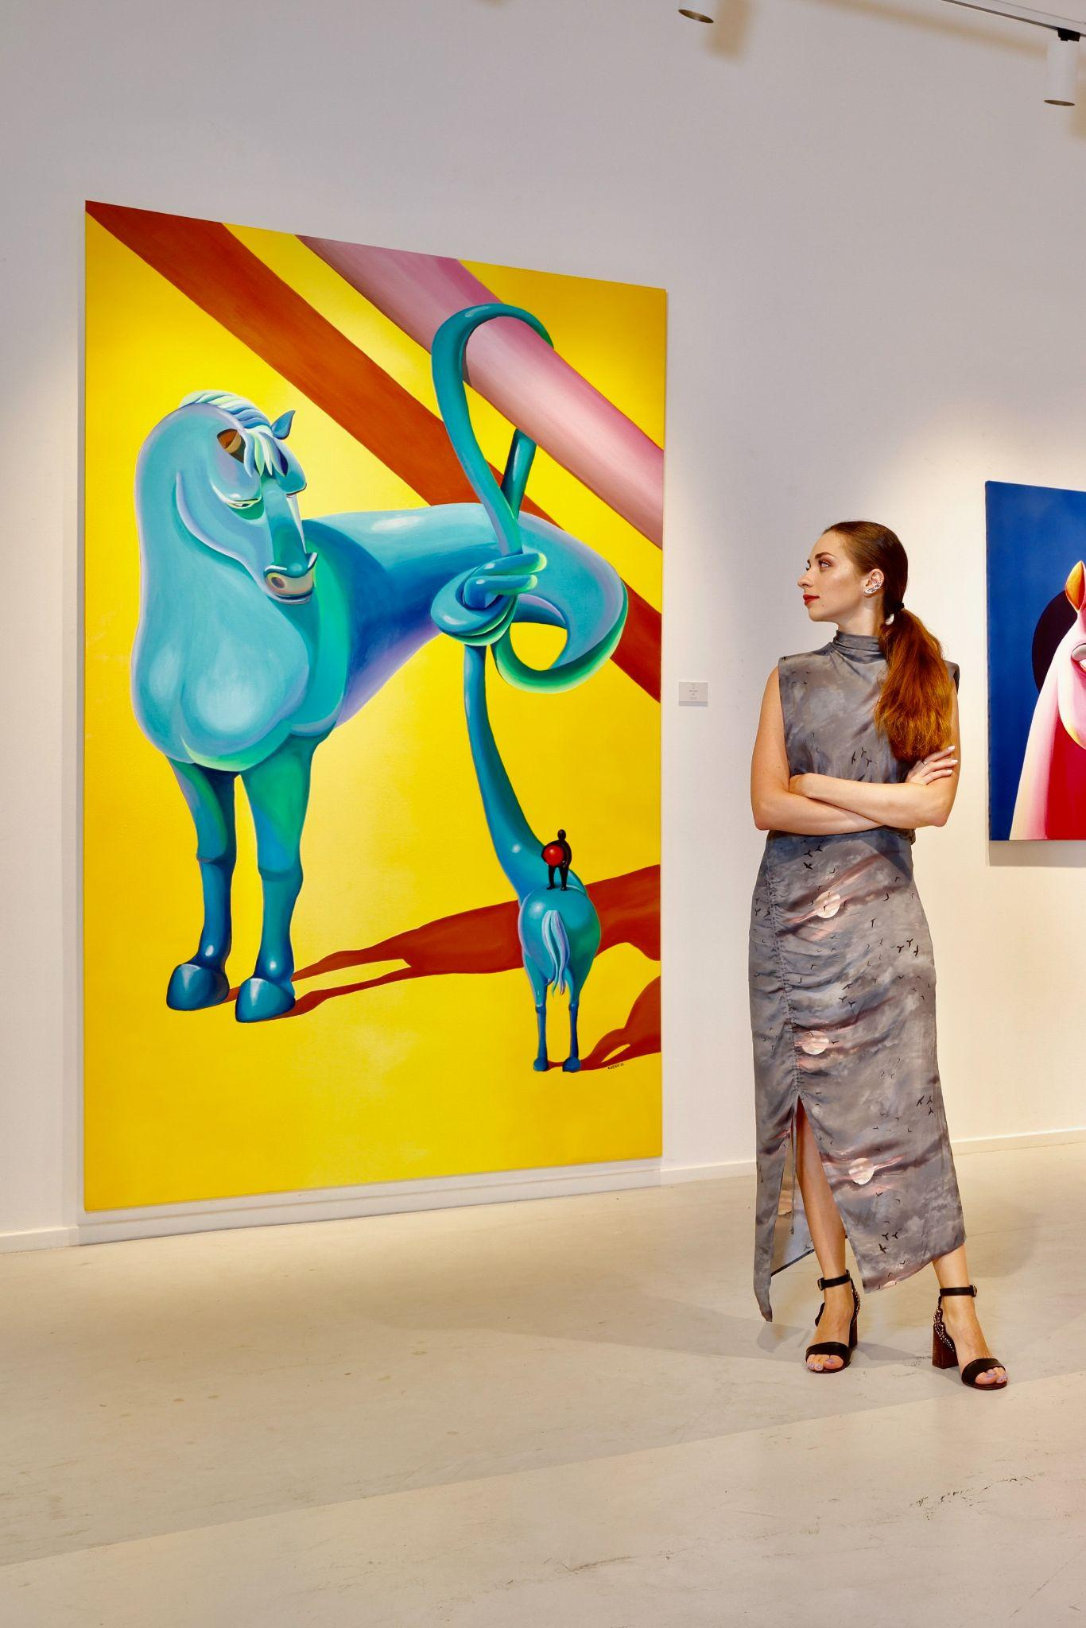
Anna Chekh with her painting ‘Twist’, 2022, price on request

After the success of Anna Chekh’s debut ‘Faceless’ exhibition in October, Skaya Art Agency, a Dubai-based boutique art consultancy, has announced new dates for the exhibition's second display in a new location at BOCCARA Gallery in Gate Avenue, DIFC, due to popular demand. Anna’s artwork features bright and vibrant colorscapes of imagination and the return of her signature element - a faceless Shadow Man that represents the desire to experience everything while staying anonymous in the shadows. The exhibition began on 17th December 2022 and is free to attend and open to the public until 10th January 2023, making it an ideal way for art admirers to spend the festive and New Year’s season.

Anna Chekh is a Ukranian contemporary artist who utilizes diverse mediums and technology to create unique experiences of interactive art. From acrylic on canvas and digital art to NFTs and performances, her art blends contemporary surrealism with expressionism to showcase current social topics through cartoonish characters. She believes that an artist’s obligation is to restore energy to society and aims to positively influence viewers through her artwork.

Anna’s debut of ‘Faceless’ in October at Oblong Contemporary Art Gallery in Dubai was a testament to the rapid growth and popularity of the NFTs market in the UAE. During the exhibition’s opening night she sold 2 NFTs and facilitated the creation of 90 NFTs by visitors through an interactive digital installation.

Throughout the Faceless collection, Anna uses an expressionless Shadow Man to symbolize society’s current generations that remove themselves from the reality of physical interactions and rely on virtual social networks to experience life while remaining anonymous as a shadow. This anonymity is multidimensional and encourages modern society to communicate through a set of programmed blueprints or disguises everyday. For example, using emojis reduces true expressions to primitive digital masks, thus enabling the communicators to be faceless. By being easy to find, yet hard to recognize, Anna’s Shadow Man in each artwork reveals society’s desire to be faceless.

Anna is currently based in Thailand and her paintings have been displayed in Dubai and held in international galleries and private collections in the USA, Germany, Italy, Ukraine. Faceless by Anna Chekh presented by Skaya Art Agency is currently hosted in BOCCARA Gallery, DIFC and will be exhibited until 10th January 2023.

To find out more visit: https://www.skayagallery.com .For more information about Anna Chekh please visit: https://www.skayagallery.com/artists/31-anna-chekh/biography/

Exhibition Information:
- Dates: 17th December 2022 - 10th January 2023 (free-to-attend and open to the general public)
- Time: 10am – 10pm (daily)
- Venue: BOCCARA Gallery, Zone D, Gate Avenue, DIFC

For more information, please visit: https://www.skayagallery.com

Click here for high resolution images

-ENDS-

Notes to editor:
About Skaya Art Agency:
Founded in 2016 by Anastasia Kopijevskaja, Skaya Art Agency is a Dubai based boutique art consultancy. With an extensive knowledge of the international art market, they represent a wide range of hand-picked artists to cater to their sophisticated taste of their clients. Their speciality is contemporary fine art, pop art and street art.
Social Media:
Instagram: https://www.instagram.com/skaya_art/
For more information, please contact:
Sarah Curtis
sarah@popcomms.ae
056 6419759

