January 2023
Media Alert

Enjoy Coffee and Art at Anna Chekh’s ‘The Shadow Man’ exhibition in a unique Cafe Art Gallery
Visitors can treat themselves to a multisensory experience by sipping on premium coffee while admiring vibrant art

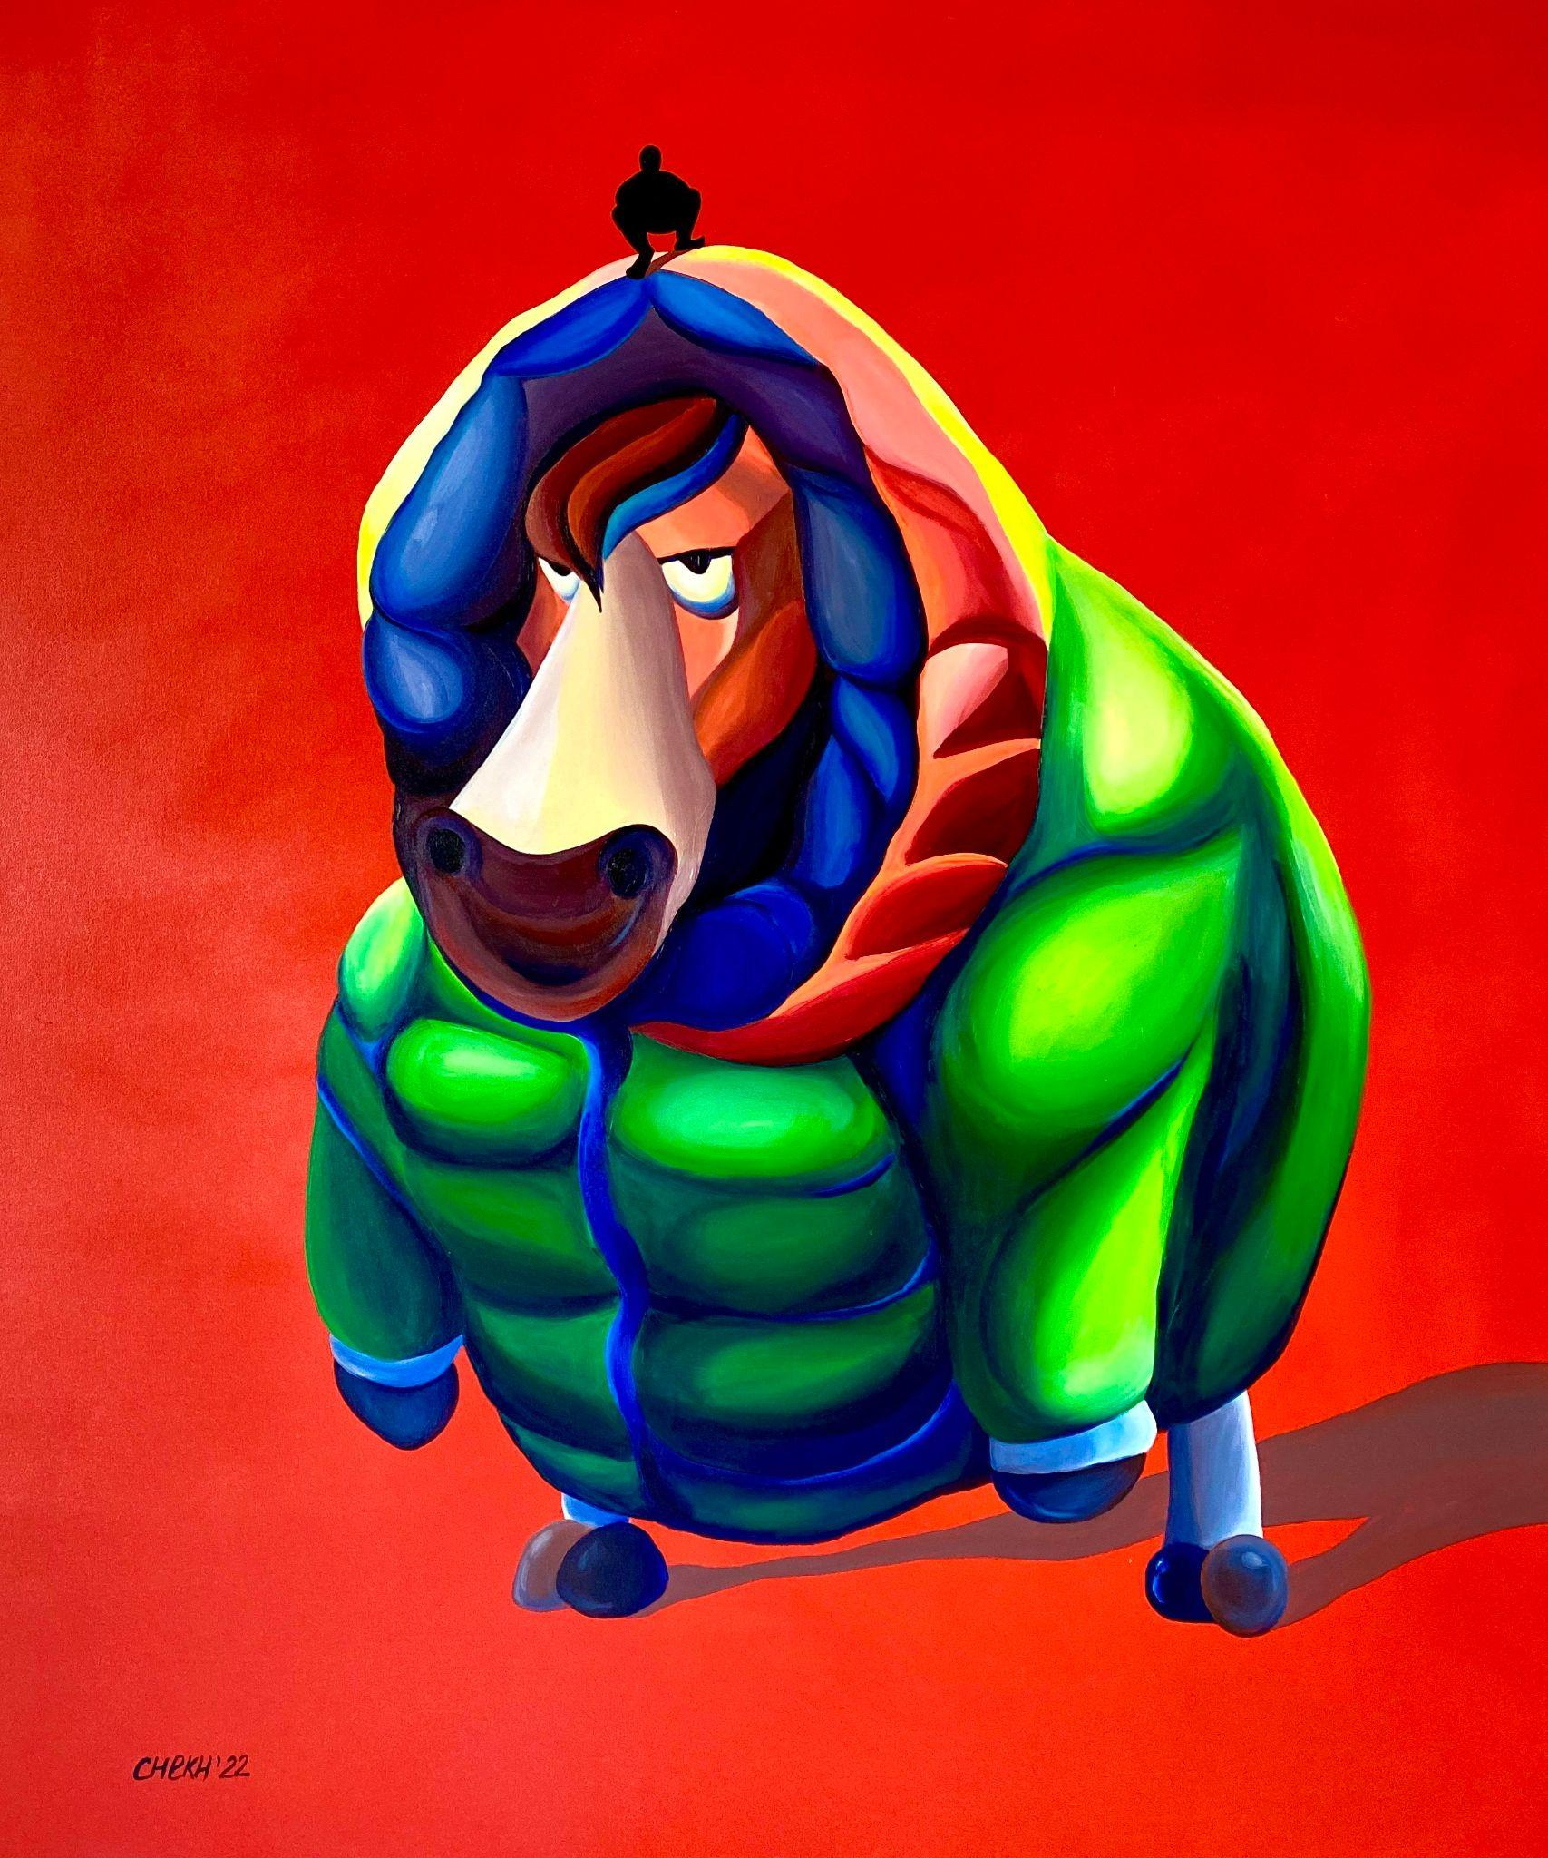
Patience, 2022 by Anna Chekh, price on request

Skaya Art Agency, a Dubai-based boutique art consultancy is proud to present Anna Chekh’s latest exhibition - ‘The Shadow Man’ in Roasters Specialty Coffee House in Jumeirah. The exhibition will feature artwork showcasing Anna’s distinctive art style of a shadow man that portrays society’s want of experiencing everything while staying unknown. Visitors will also have the chance to win a limited-edition print artwork from her collection on display through a social media competition. The exhibition will run from 23rd January to 23rd February and is free to attend making it an ideal way for art enthusiasts to view vibrant paintings with deep meanings while enjoying premium snacks and coffee.

Anna Chekh is a Ukrainian contemporary artist who uses various mediums while embracing technology and interactive art. From acrylic paintings and digital art to NFTs and live performances, her art combines contemporary surrealism with expressionism to showcase social topics through cartoonish characters. She believes that an artist should restore energy to society and aims to positively influence viewers through her artwork.

By presenting her collection in a cafe setting, Anna’s exhibition is a trendy take on evoking a multisensory experience through taste and sight. Roasters Specialty Coffee House in Jumeirah is a homegrown premium cafe with a rooftop lounge and views of the Burj Khalifa. With aesthetic interiors and a serene atmosphere, the cafe is an ideal location to dine in. Guests can complement their delicious meals and high-quality coffee with brew-tiful displays of the art on its interior walls.

Threaded throughout the art collection, a dark and faceless shadow man can be spotted. The shadow man represents society’s alter ego who emerges unannounced and wishes to experience life anonymously. It is a reflection of society’s growing isolation from real-life interactions and a shift towards behavioural patterns of virtuality. Visitors can also view a limited-edition print from the collection titled ‘Patience’ which can be won through a joint social media competition hosted by Anna Chekh and Roasters Specialty Coffee House.

Anna is currently based in Thailand and her paintings have been displayed in Dubai, Tokyo and Barcelona, and held in international galleries and private collections in the USA, Germany, Italy and Ukraine. ‘The Shadow Man’ by Anna Chekh presented by Skaya Art Agency is currently hosted in Roasters Specialty Coffee House in Jumeirah and will be exhibited until 23rd February 2023.

To find out more visit: https://www.skayagallery.com .For more information about Anna Chekh please visit: https://www.skayagallery.com/artists/31-anna-chekh/biography/

Anna’s Instagram: https://www.instagram.com/art_4eh/

Exhibition Information:
- Dates: 23rd January - 23rd February 2023 (free-to-attend and open to the general public)
- Time: 6.30am – 12am (daily)
- Venue: Roasters Specialty Coffee House, Villa 11 - 484a, Al Wasl Road, Jumeirah 2, Dubai
- Google Maps Link: https://goo.gl/maps/jCcnhHBDWZjfyn9a8

For more information, please visit: https://www.skayagallery.com

Click here for high resolution images

-ENDS-

Notes to editor:
About Skaya Art Agency:
Founded in 2016 by Anastasia Kopijevskaja, Skaya Art Agency is a Dubai based boutique art consultancy. With an extensive knowledge of the international art market, they represent a wide range of hand-picked artists to cater to their sophisticated taste of their clients. Their speciality is contemporary fine art, pop art and street art.
Social Media:
Instagram: https://www.instagram.com/skaya_art/
For more information, please contact:
Sarah Curtis
sarah@popcomms.ae
056 6419759

